Coventry University

School of Computing, Engineering and Mathematics

VT6012CEM User Experience Design

UXD Report – Group Report

Group-xx

xxx (xxx)

xxx (xxx)

xxx (xxx)

xxx (xxx)

20xx-xx

**Content**

The product 3

The goal of the evaluation / research questions 4

The goal of the evaluation is to: 4

Evaluation selection 4

Evaluation 1 4

Privacy of personal information: 4

Practical consideration 4

Equipment: 4

Evaluation plan 4

Heuristic evaluation: 4

Rule of thumb: 5

Evaluators and Evaluation Environments: 5

Result and analysis 7

List of All Positive Findings 9

Top Four Problems 10

Evaluation 2 11

Practical consideration 13

Equipment: 13

Evaluation plan 13

Case study Evaluation - User feedback collection 13

Result and analysis 15

Effectiveness 15

Efficient 16

Satisfaction 16

Easy to learn 17

Safe to use 18

Have good utility 19

Term map 19

Summary 20

The product

Parttime.hk is one of the free online jobs hunting recruitment services in Hong Kong which help job seekers find suitable jobs and help employers find practical talents. It provides employers with convenient and fast free recruitment services.

Link: <http://www.parttime.hk/>

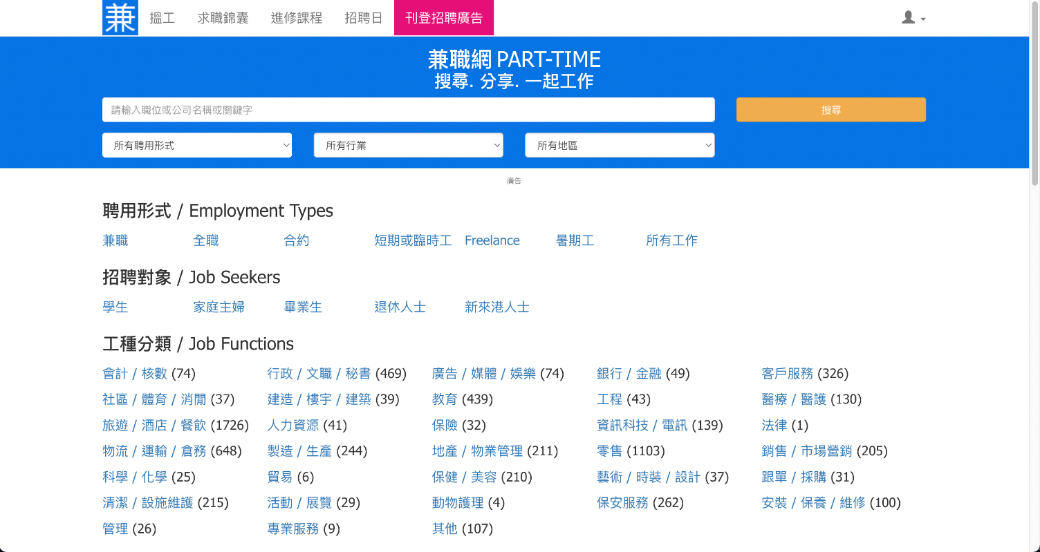

The goal of the evaluation / research questions

The goal of the evaluation is to:

* Improve the usability of job finding system
* Check the job finding system by using filter, search engine function of the website
* Find improvements
* Evaluate the effectiveness of the website
* Identify the weaknesses and the strengths
* Examine what features on this website influence user most

Evaluation selection

* Heuristic evaluation
* Usability test

Evaluation 1

Ethical consideration

Privacy of personal information:

Personal information is not required during the assessment to make sure the data would not breach.

Practical consideration

Equipment:

Projects should be evaluated on the local machines without the assistance of any other equipment therefore equipment is not required.

Evaluation plan

### Heuristic evaluation:

Heuristic evaluation is a process where experts use rules of thumb to measure the usability of user interfaces in independent walkthroughs and report issues. Evaluators use established heuristics (e.g., Nielsen-Molich's) and reveal insights that can help design teams enhance product usability from early in development.

Revised version (2014) of Nielsen’s original heuristics

### Rule of thumb:

- Visibility of system status

- Match between system and real-world

- User control and freedom

- Consistency and standards

- Error prevention

- Recognition rather than recall

- Flexibility and efficiency of use

- Aesthetic and minimal design

- Help users recognize, diagnose, recover from errors

- Help and documentation

### Evaluators and Evaluation Environments:

The system evaluation environments used by each evaluator are shown in Table.

|  |  |  |  |  |
| --- | --- | --- | --- | --- |
| Evaluator | A | B | C | D |
| Age | 24 | 30 | 24 | 25 |
| Sex | male | male | male | male |
| Device | Personal Computer | Personal Computer | Personal Computer | Personal Computer |
| OS and Version | Window 11 | Window 11 | Window 10 | Window 10 Pro |
| Screen Size | 1920*1080  27” 144hz | 27” 144hz  1920*1080 | 27’’  1920*1080  280hz | 34”  21:9 144hz |
| Screen Resolution | 1920*1080 | 1920*1080 | 1920*1080 | 3440*1440 |
| Web Browser | Chrome 99.0.4844.74 (64-bit) | Chrome 99.0.4844.74 (64-bit) | Chrome  99.0.4844.74  (64-bit) | Chrome  99.0.4844.74  (64-bit) |
| Ad Blocker | AdBlock | AdBlock | AdBlock | AdBlock+ AdBlock for YouTube |
| Internet Connection | LAN | LAN, Wi-Fi 6 5GHz | 2.5Gb LAN,  WiFi 6 AX200 (802.11ax) | 2.5Gb LAN, WiFi |
| Download Speed | 1000 Mbps | 1000 Mbps | 1000 Mbps | 1000Mbps |
| Browser Resolution | 1920 *720 | 1920 * 1080 | 1920*1080 | 3440*1440 |
| Screen Recording Software | GeForces Experience  Cap Screen | GeForces  Experience  Cap Screen | GeForces  Experience  Cap Screen | GeForces  Experience  Cap Screen |
| Date of Evaluation | 2022/3/18 | 2020–3-18 | 2022-03-18 | 2022-03-18 |
| Time of Evaluation | 15:00-17:30 | 15:00-17:30 | 15:00-17:30 | 15:00-17:30 |

Result and analysis

|  |  |  |
| --- | --- | --- |
| Type of evaluation | How well addressed  (Meets/ Barely Meet /Does not Meet) | Comments |
| Visibility of system status | Barely Meet | Some of the page websites do not clearly state.  Although this is common on many websites. |
| Match between system and real-world | Does not Meet | Icon use text only  Not user-friendly to people who do not know Chinese. |
| User control and freedom | Barely meet | While user mistaken choose a job type, not clearly back function  Can reverse back action  employer page has no clear idea to Switch back to employee  Only a text button |
| Consistency and standards | Does not meet | Color and design are different at each page |
| Error prevention | Meet | have Email spelling checking  All required fields, avoid empty input |
| Recognition rather than recall | Does not meet | No recognition of history  Title should be changed to other color for better recognition |
| Flexibility and efficiency  of use | meet | Remarkably plain design |
| Aesthetic and minimalize design | meet | Good, all functions are related to the website |
| Help users recognize,  diagnose, recover from errors | meet | precisely indicate the problem, and constructively suggest a solution. |
| Help and documentation | Does not meet | No instructional or frequently asked question (FAQ) |

4 Results of the Evaluation

This section describes the results of the heuristic evaluation.

### List of All Positive Findings

The above table shows a list of all the positive findings which emerged from the evaluation, sorted in decreasing order of average (mean) positivity, i.e., the most positive are at below.

|  |  |
| --- | --- |
| Type of evaluation | Result |
| Error prevention | Positive |
| Flexibility and efficiency of use | Positive |
| Aesthetic and minimalize design | Positive |
| Help users recognize,  diagnose, recover from errors | Positive |

### Top Four Problems

The top four problems according to their average (mean) severity type are described in more detail below. The problem (negative finding) with the highest mean severity. The severity type scheme used for the problems is shown in the table.

|  |  |
| --- | --- |
| Type of evaluation | Result |
| Match between system and real-world | negative |
| Consistency and standards | negative |
| Recognition rather than recall | negative |
| Help and documentation | negative |

#### Problem 1: Icon

The main problem is the text-based icon. Not only it is unfriendly to people who don’t know Chinese, but it also hard to understand what it is for without clearly watch and understand the meaning of words.

To reproduce the problem, by clicking to the website, you will be able to see the design of the website is using many text-based button.

#### Problem 2: Layout

The main problem is the webpage layout and style. Some of the page Style remain the same, but if you are employer and an employee, you will see the layout of these two pages is different.

#### Problem 3: history function for user to recall

The main problem is that the system will not record user action, when user want to close the windows. When user want to start finding the job. The system will lead user to find the job which is viewed before.

#### Problem 4: no back function and not clear system status

The problem is the website doesn’t have previous function and a clear system status. If the user browses the job’s page first, he/she cannot go to the type of jobs that he/she was browsed.

Evaluation 2

Ethical consideration

Privacy of personal information:

**Personal information is not required during the assessment to make sure the data would not breach.**

**Develop a consent form**

Although the user’s personal information is not involved in the evaluation process, the user would still be required to sign a consent form before the evaluation begins to prevent privacy issues that may occur during the process.

|  |
| --- |
| **Consent form** |
| Dear Sir/Madam:    You are cordially invited to participate in this survey. Please read the consent form below before participating in this study, and if you understand the statement and agree to participate in the study, please proceed to fill out this questionnaire.    The content of the questionnaire will consist of 2 parts. You first need to complete the specified job search based on the task. Next, you will be asked how the user experience and part of the operation feels during this process.    The results of this survey and the personal data collected will be kept strictly confidential. Participation in this research will be anonymous and voluntary, participation will not affect your rights in any way, and you have the right to withdraw from this research at any time. Completing this questionnaire constitutes your agreement to participate in this research.  Username: _____________  Signature: _____________  Date: _____________ |

**Delete all the personal information after the evaluation**

**If the user’s personal information is involved or appears during the evaluation process, would be deleted all after the evaluation is completed**

Practical consideration

Equipment:

Projects should be evaluated on the local machines without the assistance of any other equipment therefore equipment is not required.

Evaluation plan

### Case study Evaluation - User feedback collection

1.Task:

Please carry out the following task. Please speak aloud and say what you are doing as you attempt the task:

|  |
| --- |
| Open <http://www.parttime.hk/> in any browser and looking for a part-time job for housewife which can only work 4hr a day. When you have found one, please say ‘found one’, and that’s the end of the test. |

2.User Feedback

After the session has been completed, please fill in the following:

A). Usability

|  |  |  |
| --- | --- | --- |
| Goal | Metric | Value |
| Effectiveness | Completed within 2 minutes | (Yes / No) |
| Efficient | Count clicks to find the job | Number |
| Satisfaction | 1-Strongly disagree; 2-Disagree; 3-Undecided; 4-Agree; 5-Strongly agree | 1-Strongly disagree;  2-Disagree;  3-Undecided;  4-Agree;  5-Strongly agree |
| Easy to learn | Confuse about how to start finding for a job | (Yes / No) |
| Safe to use | fault occurs or is taken to the wrong page | (Yes / No) |
| Have good utility | Task difficult to accomplish | (Yes / No) |

B) Term map (Highlight those terms which can describe your experience)

Cool Fresh Exciting Boring Nice

Intriguing Fun Annoying Beautiful

Slick Satisfying Clever Interesting

Rewarding Slow Eager smooth

Disappointed Stressed Confused hesitant

C) What other terms would you use to describe your experience (if any)?

|  |
| --- |
|  |

Result and analysis

### Effectiveness

Completed within 2 minutes

In this task, the user must find a job in two mins. This evaluation uses whether different users can complete the test within a time limit. There had 4 users who could complete the task in 2 minutes. And no users who can't complete the task in 2 minutes. Passed users for 100% of the total number of users.

### Efficient

In the evaluation, the user needs to complete the specified task within 2 minutes, therefor the feedback would ask the user the number of keystrokes required to complete the task to observe the efficiency of the website. According to the chart all users have less than 10 keystrokes to complete the task, reflecting the operation is very concise and smooth.

### Satisfaction

Satisfaction will be represented by a score of 1-5 to strongly disagree to strongly agree. According to the chart, 50% of 4 users are feel satisfied with this test. 25% of 4 users feel Strongly Disagree or Undecided with this test.

### Easy to learn

This evaluation tests the user's ease of use of the system. There had 1 user agree confused about how to start finding a job. And 3 users disagree confused about how to start finding a job. Agree user for 25% of the total number of users. Disagree user for 75% of the total number of users.

### Safe to use

This evaluation tests that there are enough prompts and returns to the correct test when a user fails or is taken to an error page. There had 1 user agree Fault occurs or is taken to the wrong page. And 3 users disagree Fault occurs or is taken to the wrong page. Agree user for 25% of the total number of users. Disagree user for 75% of the total number of users.

### Have good utility

One of the main purposes of the evaluation is the utility of the website, and the utility of this project is reflected in the possibility of jobs for users. According to the data in the chart, half of the users who feel useful and half of the users not practical to the website. In that light, the usefulness of the website may need to be improved.

### Term map

Nice, intriguing, Clever, Smooth

Annoying, Slow, Stressed, Confused

Nice, Satisfying

Fresh, Interesting, Slow, Confused

Summary

After researching in use case, it was found that Parttime.hk have some improvement to make. Although most result is promising and most user found it satisfied and accomplish the task on time, some result shown that some user may found the website not easy to use and will lead to the wrong page.

Finally, another research method was conducted by professional to found out what the weaknesses and the Strength of the website. The result shown 4 main possible improvement which is Match between system and real-world, Consistency and standards, Recognition rather than recall and help and documentation.